**Scratch Catching Game Guide**

We can break the game down into 5 parts

* Move the character
* Make object go to the top
* Make object fall down
* Catch the object
* Keep Score

We will start with creating our character and programming it to move left and right. Let’s begin!

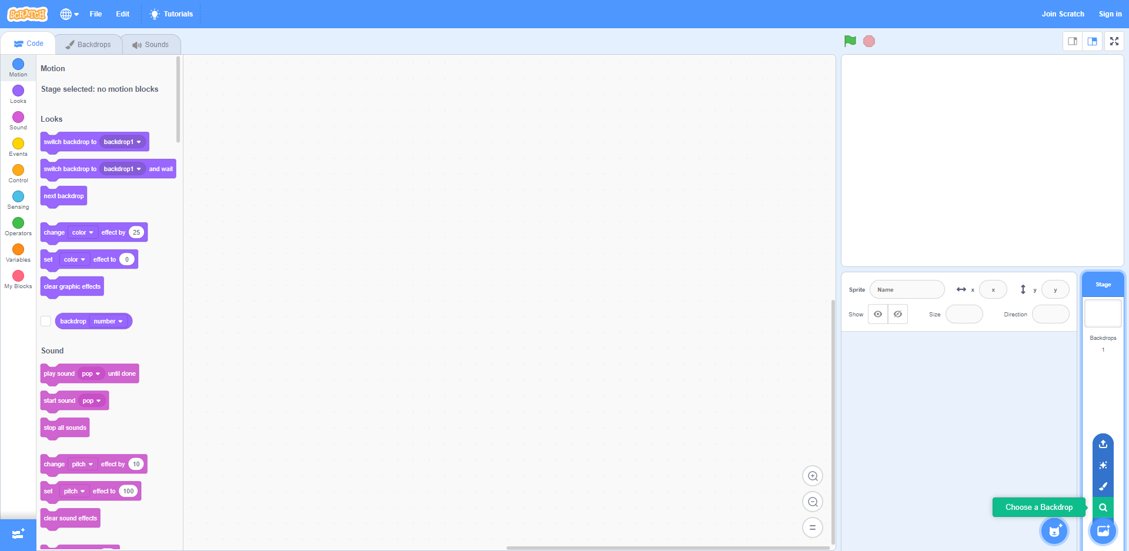Step 1: Hover your mouse over the backdrop icon on the bottom right and click the magnifying glass that says, “Choose a Backdrop.”

Step 2: Find a backdrop that you like and click on it.

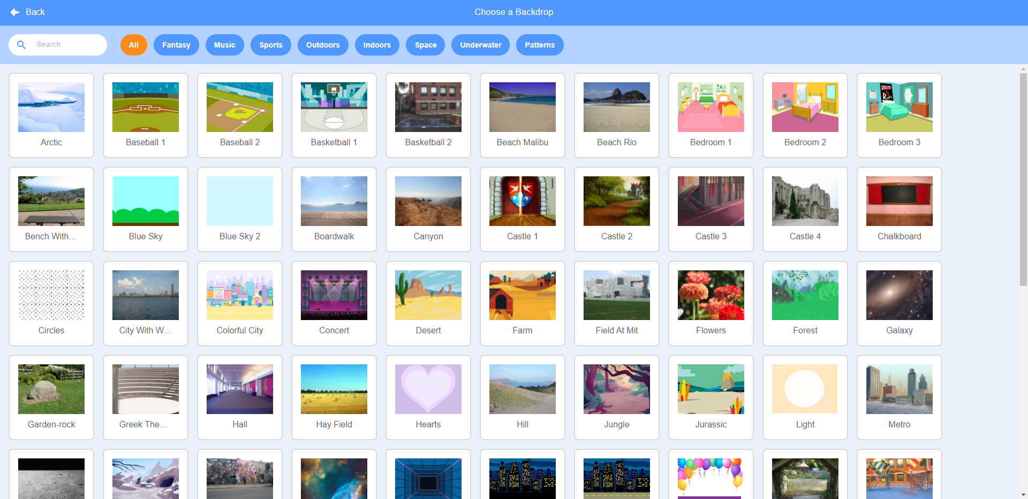

Step 3: Hover over the Sprite icon to left of the backdrop icon and click the magnifying glass that says, “Choose a Sprite.”

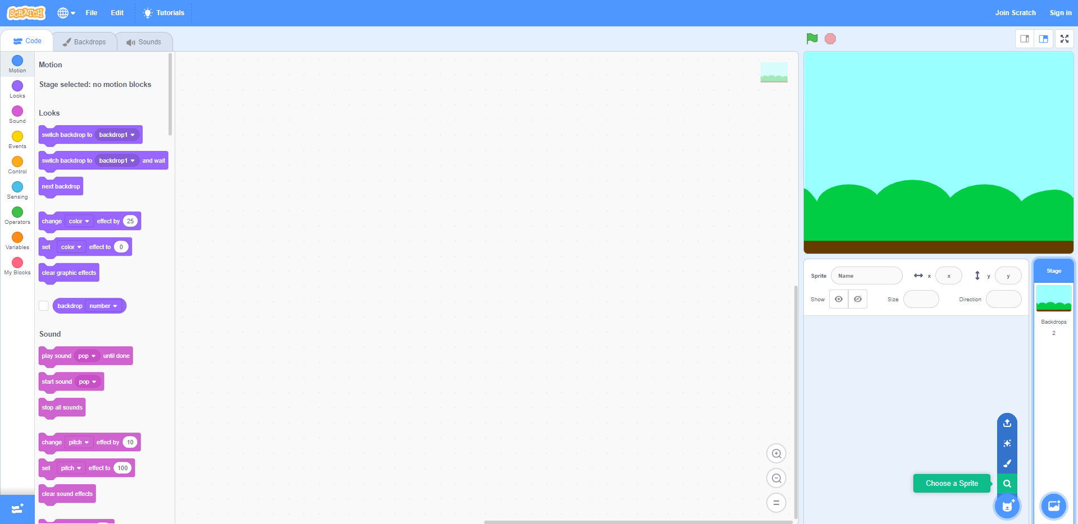

Step 4: This will be your character sprite, find a character that you like and click on it.

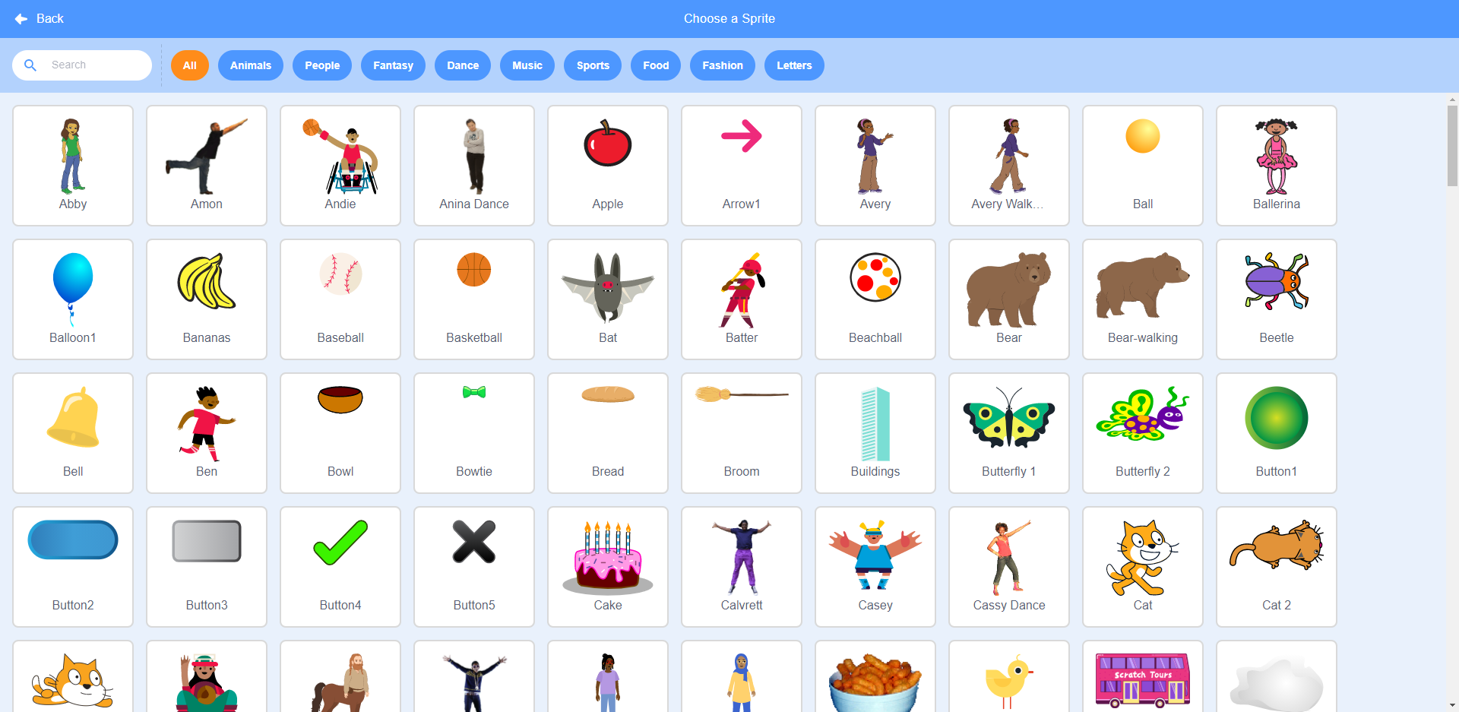

Step 5: You can easily adjust the position of your character by clicking and dragging your character in the game window on the top right. You can also adjust the size of your character by typing a new number in the “Size” text box. To center the character horizontally, type the number 0 in the “x” text box, which is above the “Size” text box.

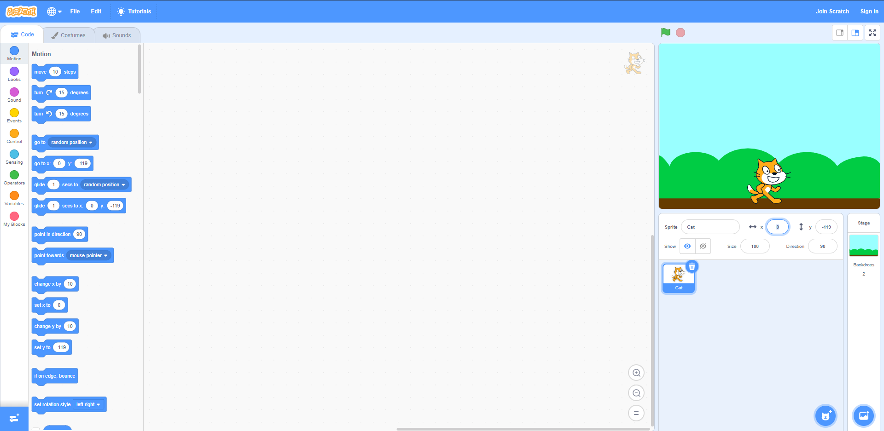

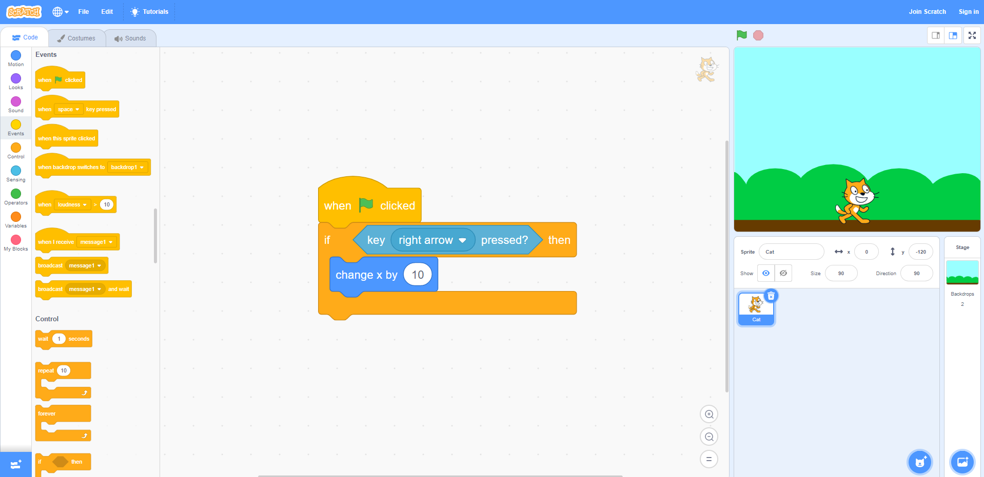Step 6: We want the character to be able to move side to side with the arrow keys. To do this, in the “Motion” category, we need the “change x by __” block. Change the number to 10. You will find that when you click it, the character moves to the right. Now we need to put it in an if statement. We will also need a “key __ pressed?” block in the “Sensing” category. Change the key to “right arrow key”. Create your if statement with the sensing block as the condition, and the motion block after the “then.” Add a “when green flag clicked” block to the top for testing.

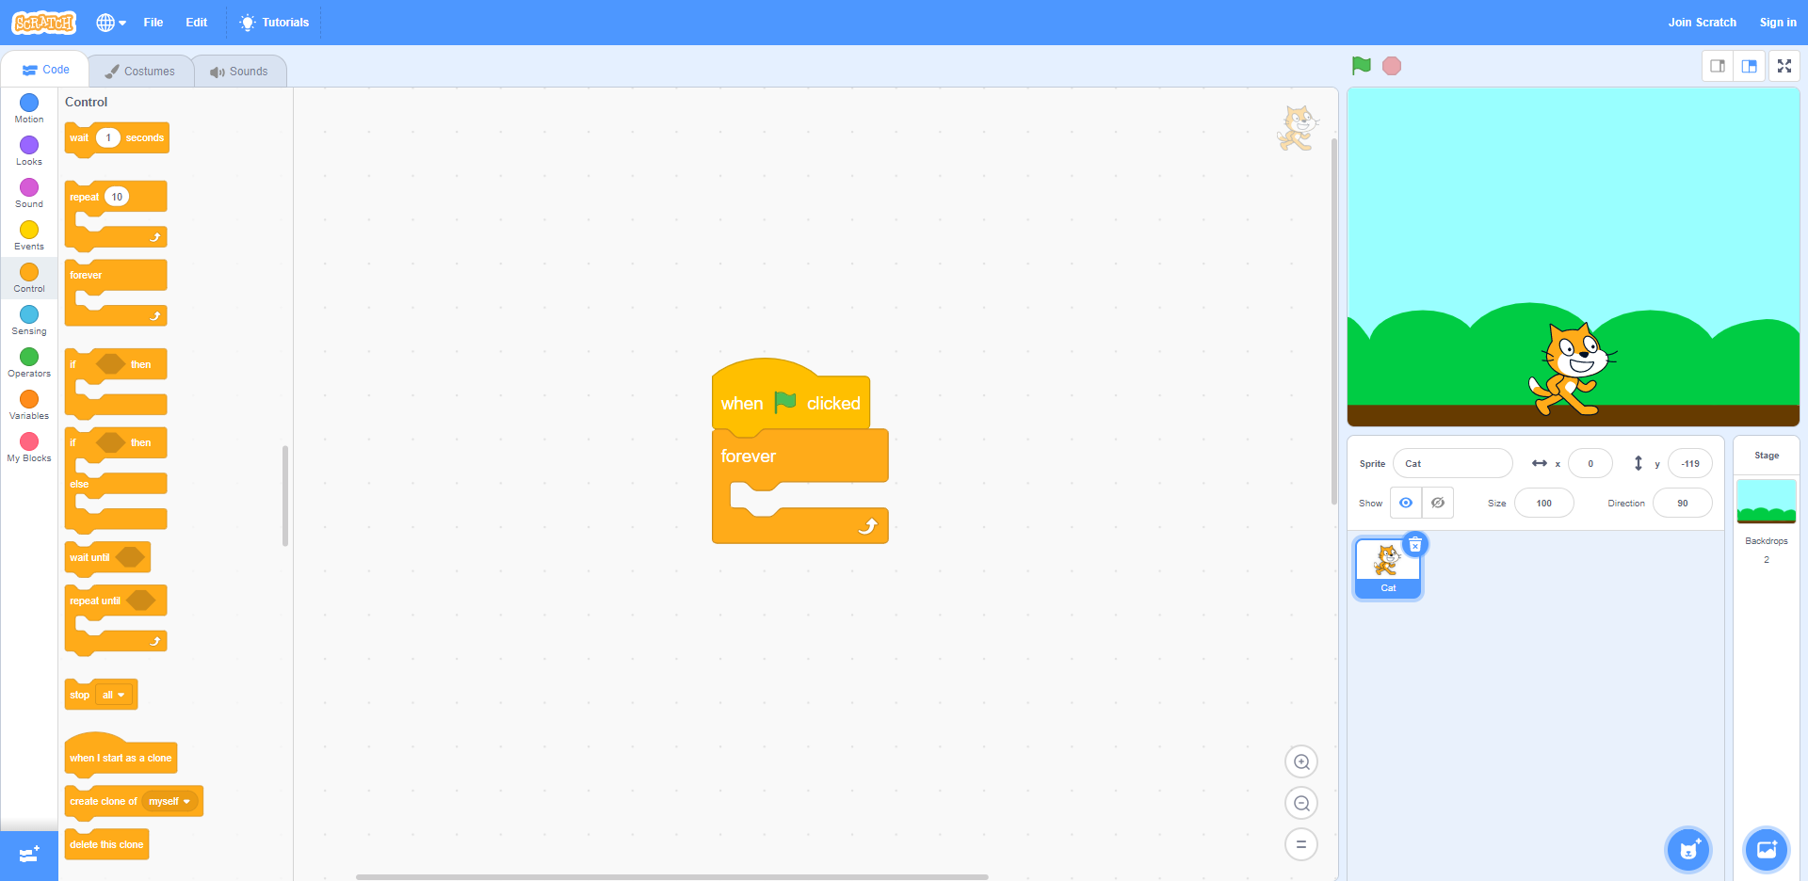Step 7: If we try to move our character we run into a problem. The if statement is checking the condition only once. We want our game to be checking the condition continuously. We will need a “forever” loop block from the “control” category. Move your “when green flag clicked’ block to the top of the “forever” block.

Step 7: Before we place our if statement into the forever loop, we need our character to be able to move left. Do the same as we did before but change the key to “left arrow key’ and change x by -10 instead of 10.

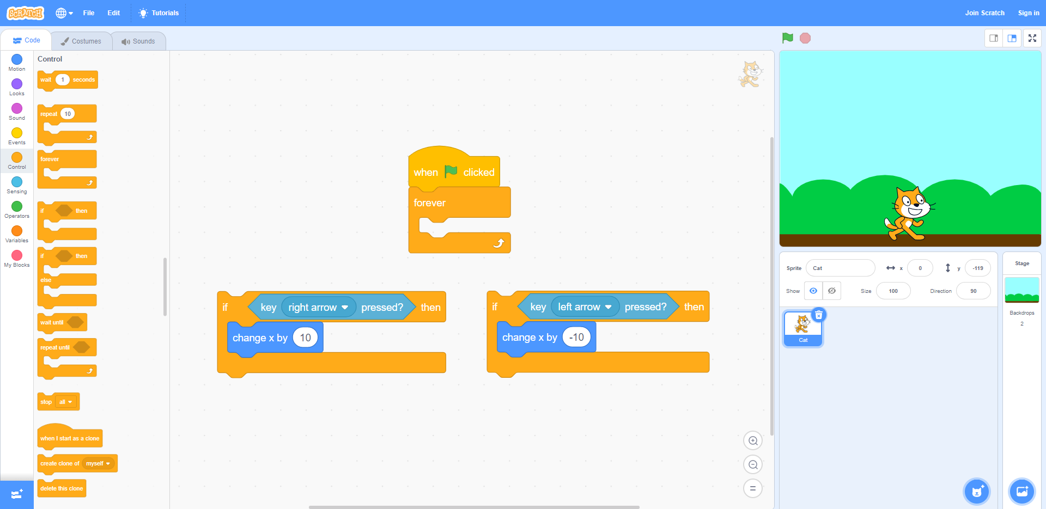

Step 8: Place the if statements in the forever loop. The order does not matter. This way, our game is constantly checking to see if the user has pressed the left or right arrow key and will move the character.

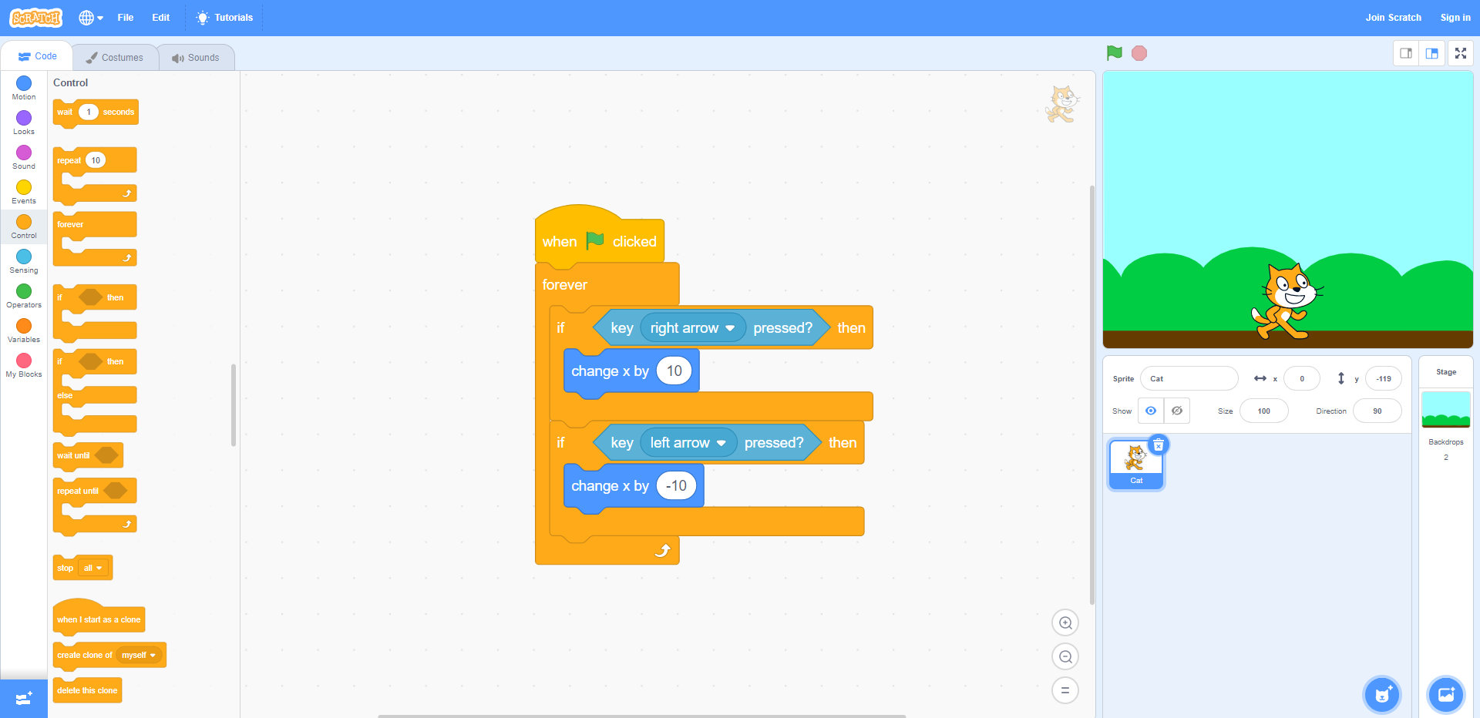

That concludes part one “Move the character.”

We have created a character that is controlled with the left and right arrow keys. We can now move on to part two.

Let’s create the object we will be catching and have it start at the top of the screen!

Step 1: Hover over the Sprite icon to left of the backdrop icon and click the magnifying glass that says, “Choose a Sprite.”

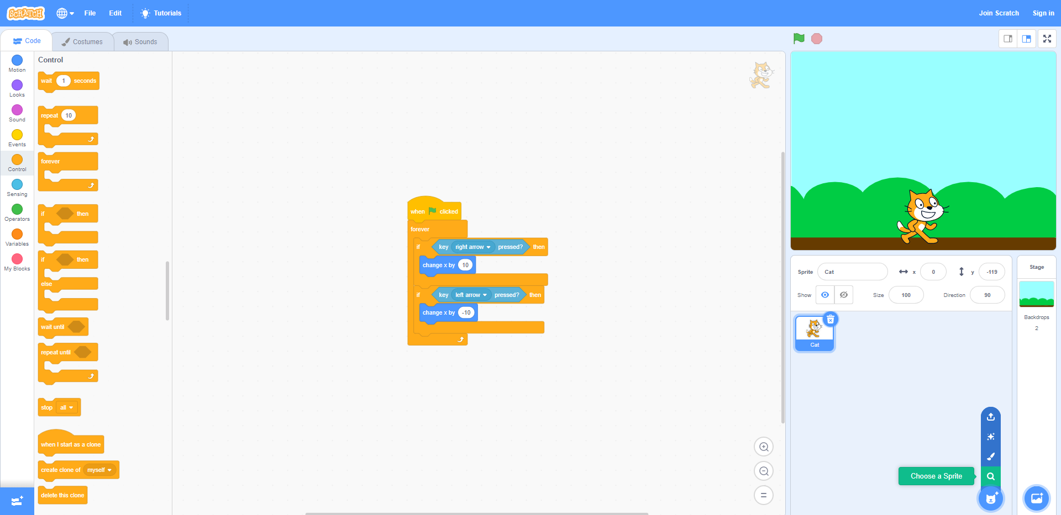

Step 2: This will be your object sprite, find an object that you like and click on it.

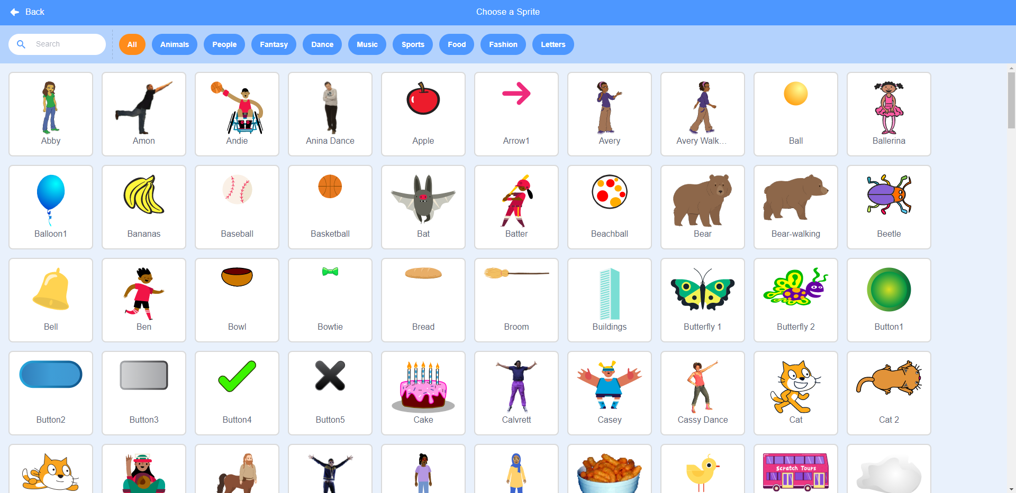

Step 3: Drag and drop a “when green flag clicked” block from the “Events” category. Drag and drop a “go to random position” block and a “set y to __” block from the “Motion” category. Change the value of y to “180.” y = 180 is the top of the screen in Scratch. When the game starts, the object will go to a random position and always at the top of the screen.

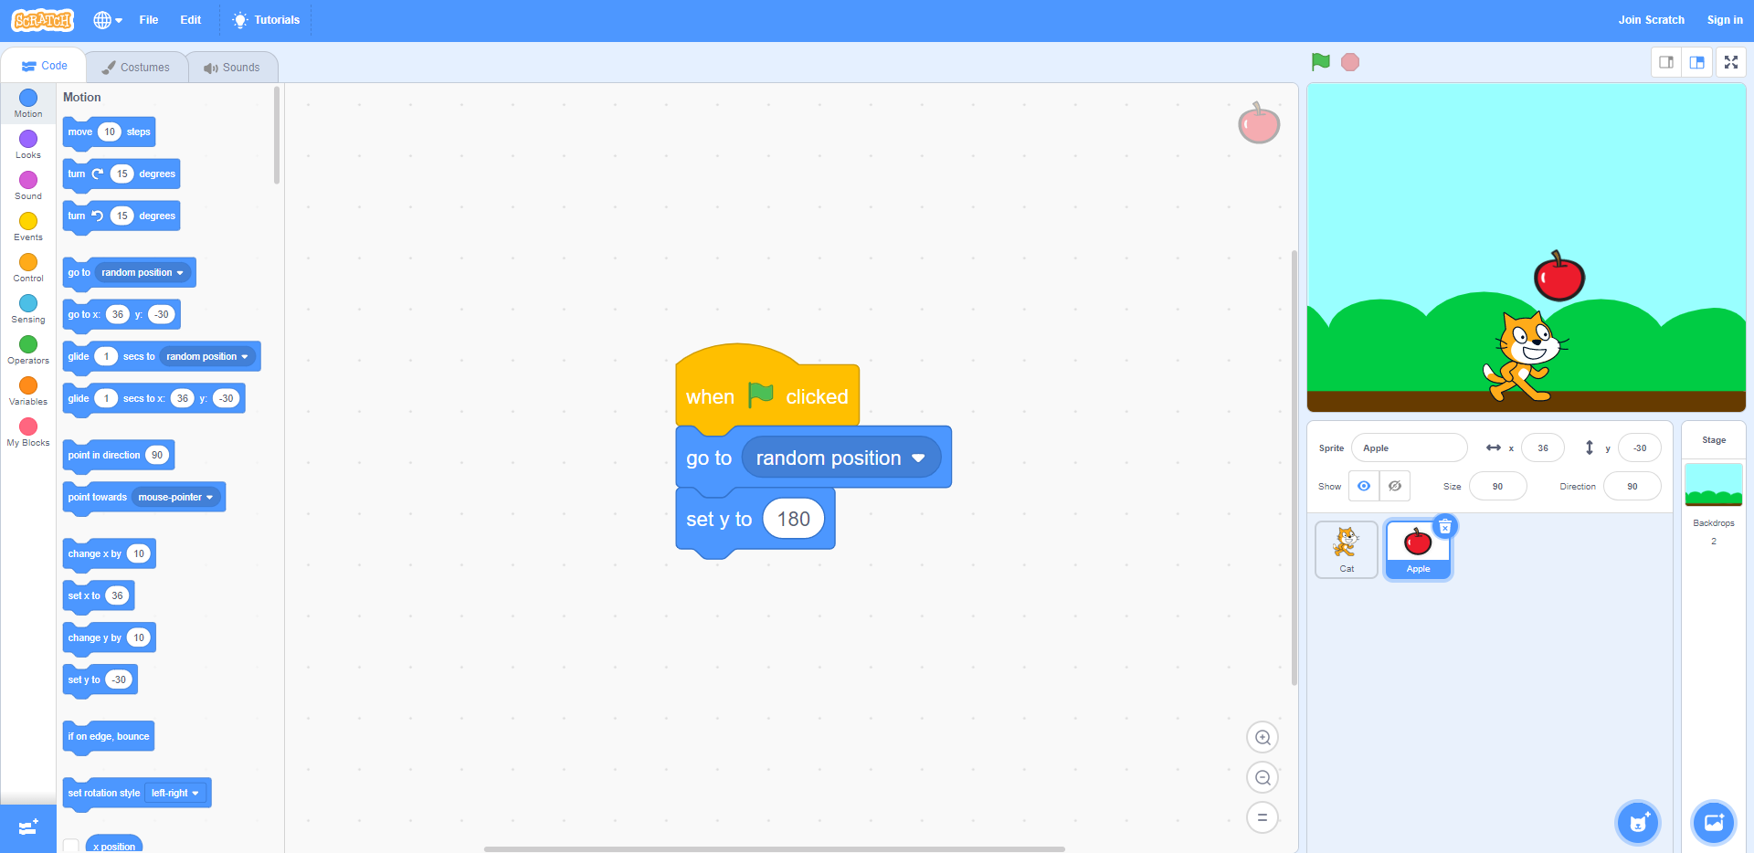

That concludes part two “Make object go to the top.”

We have created an object that starts at a random place at the top of the screen.

Now, let’s make our object fall down!

Step 1: Drag and drop a “forever” loop block from the “Control” category. Drag and drop a “change y by __” block in the “Motion” category into the forever loop. Change the value to “-5.” Now we have an object that falls, but only one time. We want the object to go back to the top if it is at the bottom.

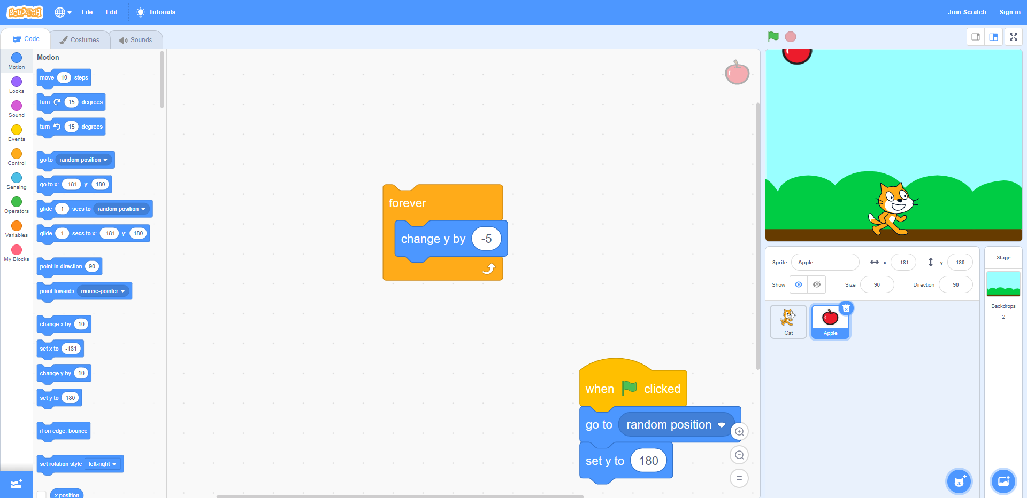

Step 2: Drag and drop an “if” statement block from the “Control” category. The object is at the bottom when y > -170. At the bottom of the “Motion” category, drag and drop a “y position” block. In the “Operators” category, drag and drop a “__ > 50” block. This block checks if what is on the left is less than the right. We want to check if y is less than 170. Place the green block in the if statement and place the “y position” block in the green block. Change the value from “50” to “-170.”

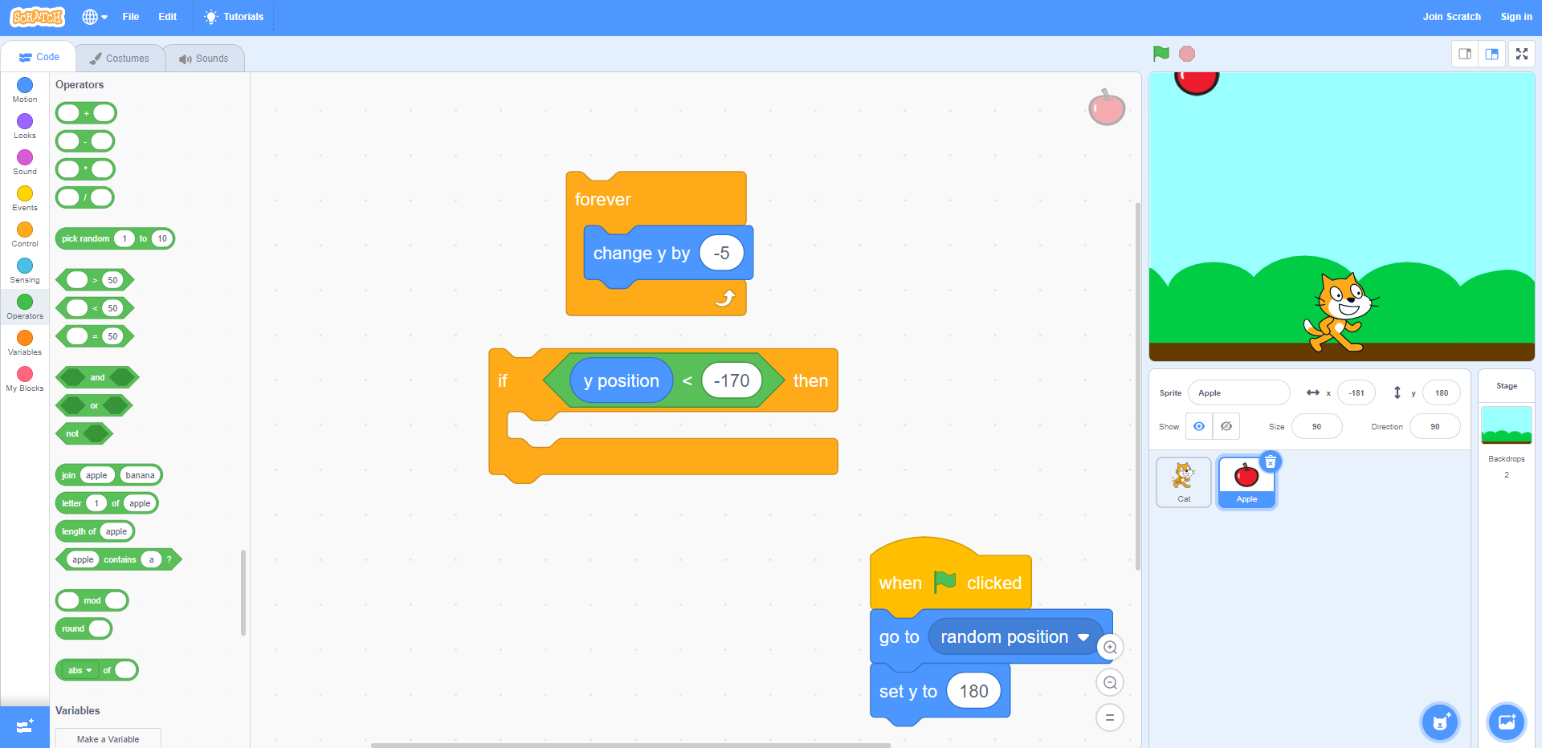

Step 3: Now, if the object is at the bottom, what do we want it to do? We want the object to go back to the top. Well we already have the code for that, we just need to copy it. Drag and drop another “go to random position” and “set y to 180” block, but this time inside our if statement. Now place the entire if statement into our forever loop. Also add a “when green flag is clicked” block to the top of the forever loop.

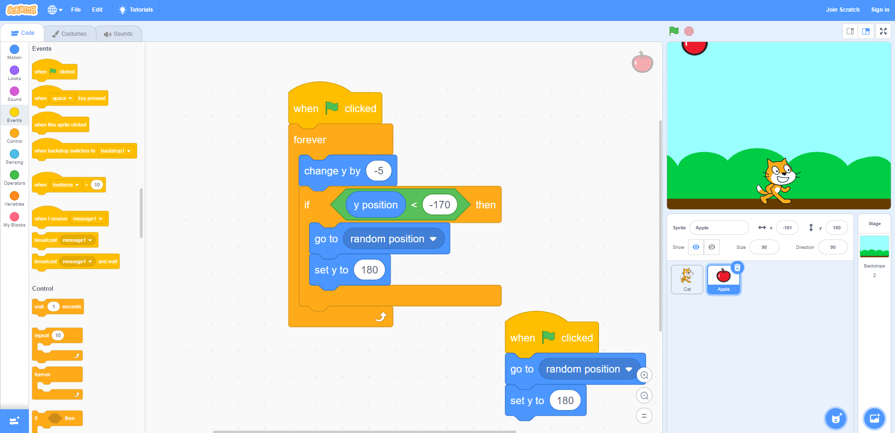

That concludes part three “Make object fall down.”

We have an object that can fall. When it gets to the bottom, it goes back to the top.

Now let’s make it so we can catch the object!

Step 1: If the object touches the character, then the character caught it. So, the object should stop falling and go back to the top to fall again. Drag and drop another if statement. In the “Sensing” category, drag and drop a “touching mouse-pointer?” block into your if statement. instead of “mouse-pointer” click the drop-down menu and select your character. Now the block will test if the object is touching your character.

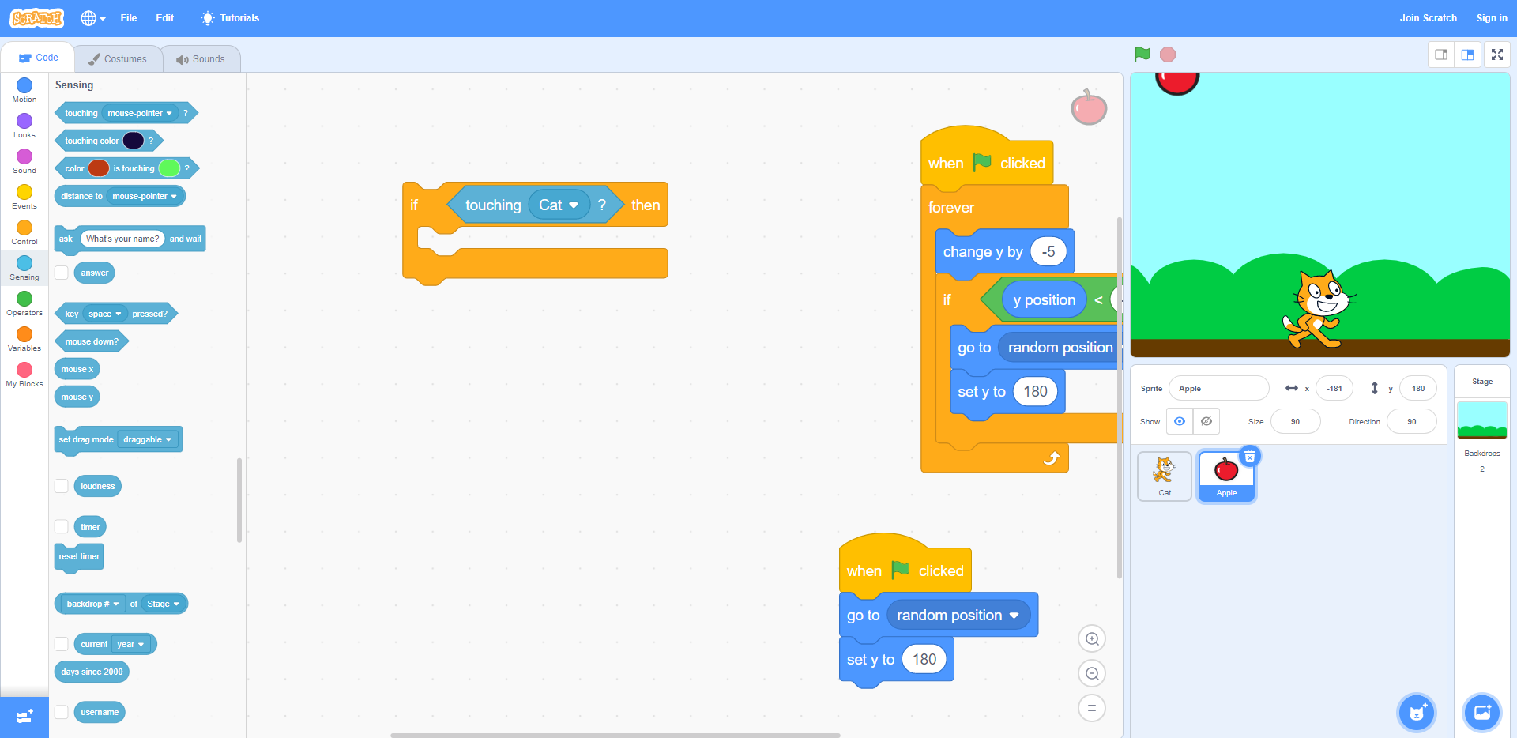

Step 2: Do the same as you did previously to make the object go back to the top after the condition in the if statement is met (go to random position, set y to 180). Put this all in a forever loop with a “when flag clicked” block at the top.

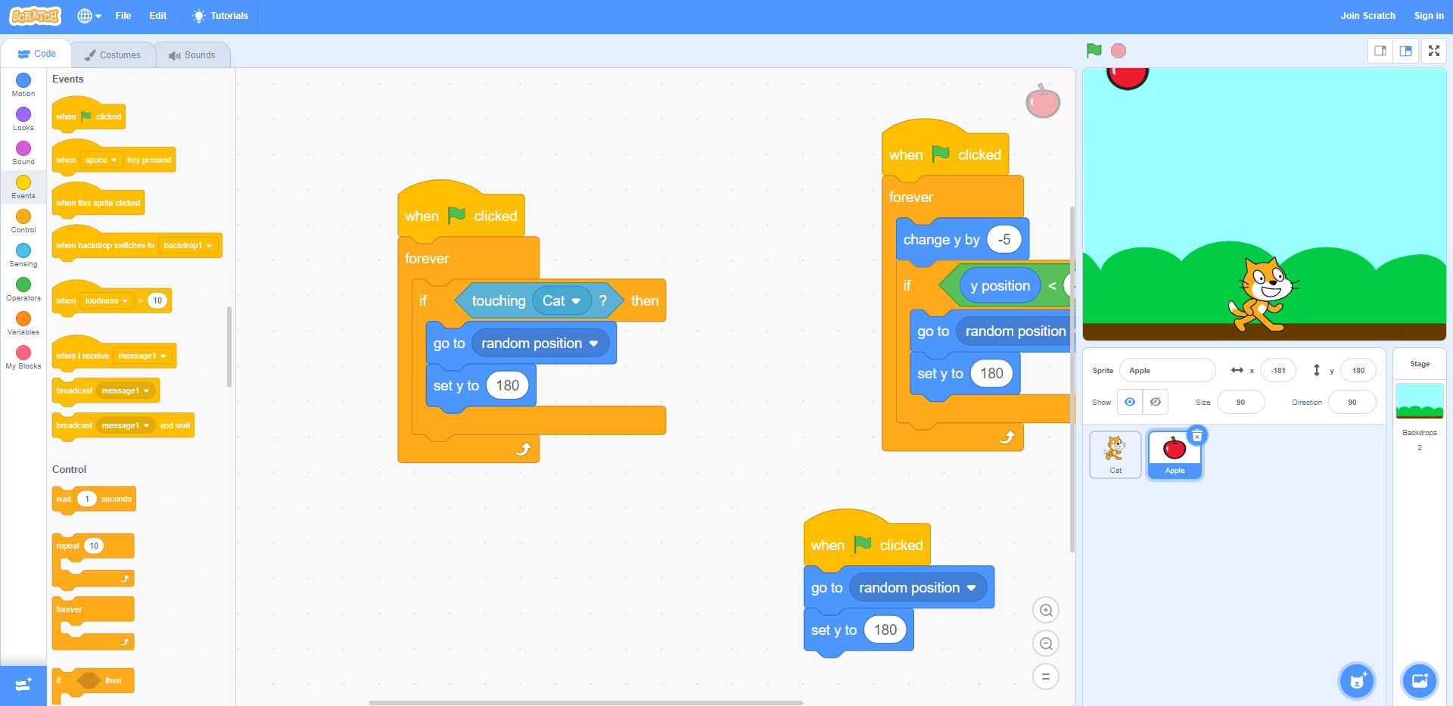

Step 3: Just for fun, lets make it play a sound when the object is caught. In the “Sound” category drag and drop a “start sound __” block into the if statement. You can change the sound to whatever you like with the drop-down menu.

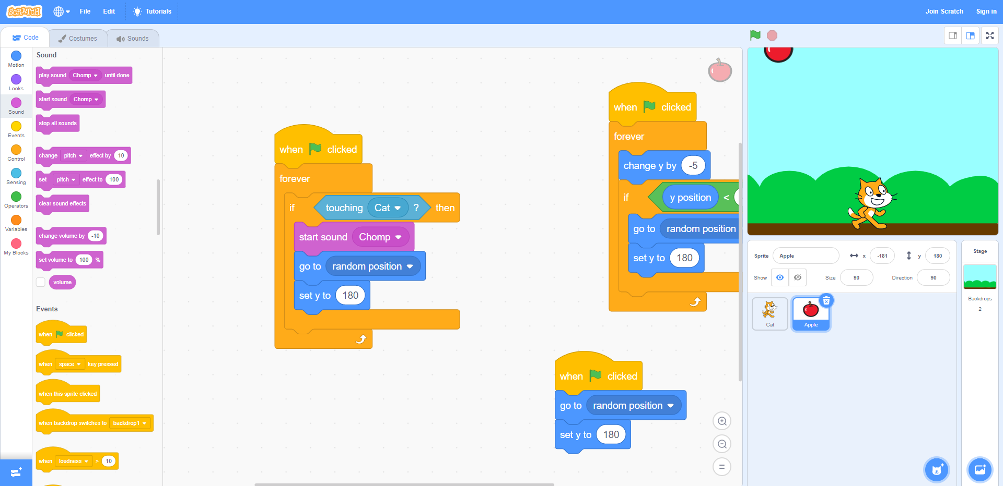

That concludes part four “Catch the object.”

The object now returns to the top of the screen when it touches our character. Now we need to somehow get point for every object we catch.

Lastly, let’s add a score!

Step 1: To add a score, we have to add a variable. A variable lets you keep track of a certain number in your project. Under the “Variable” category, click “Make a variable.” name the variable “Score” and click “OK.”

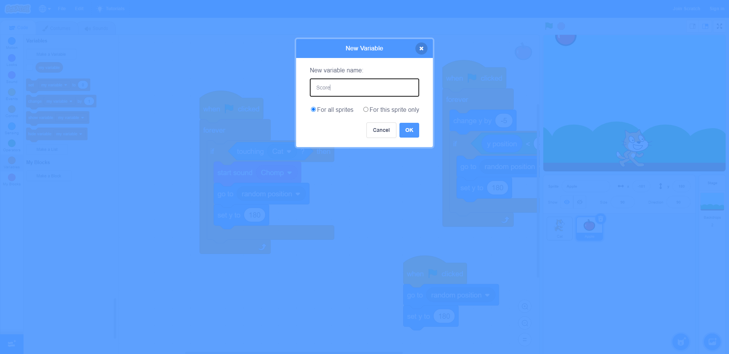

Step 2: Drag and drop the “change my variable by 1” block. Place it in the if statement so that every time we catch the object, the score increases by 1. Click the drop-down menu to select the variable “Score.”

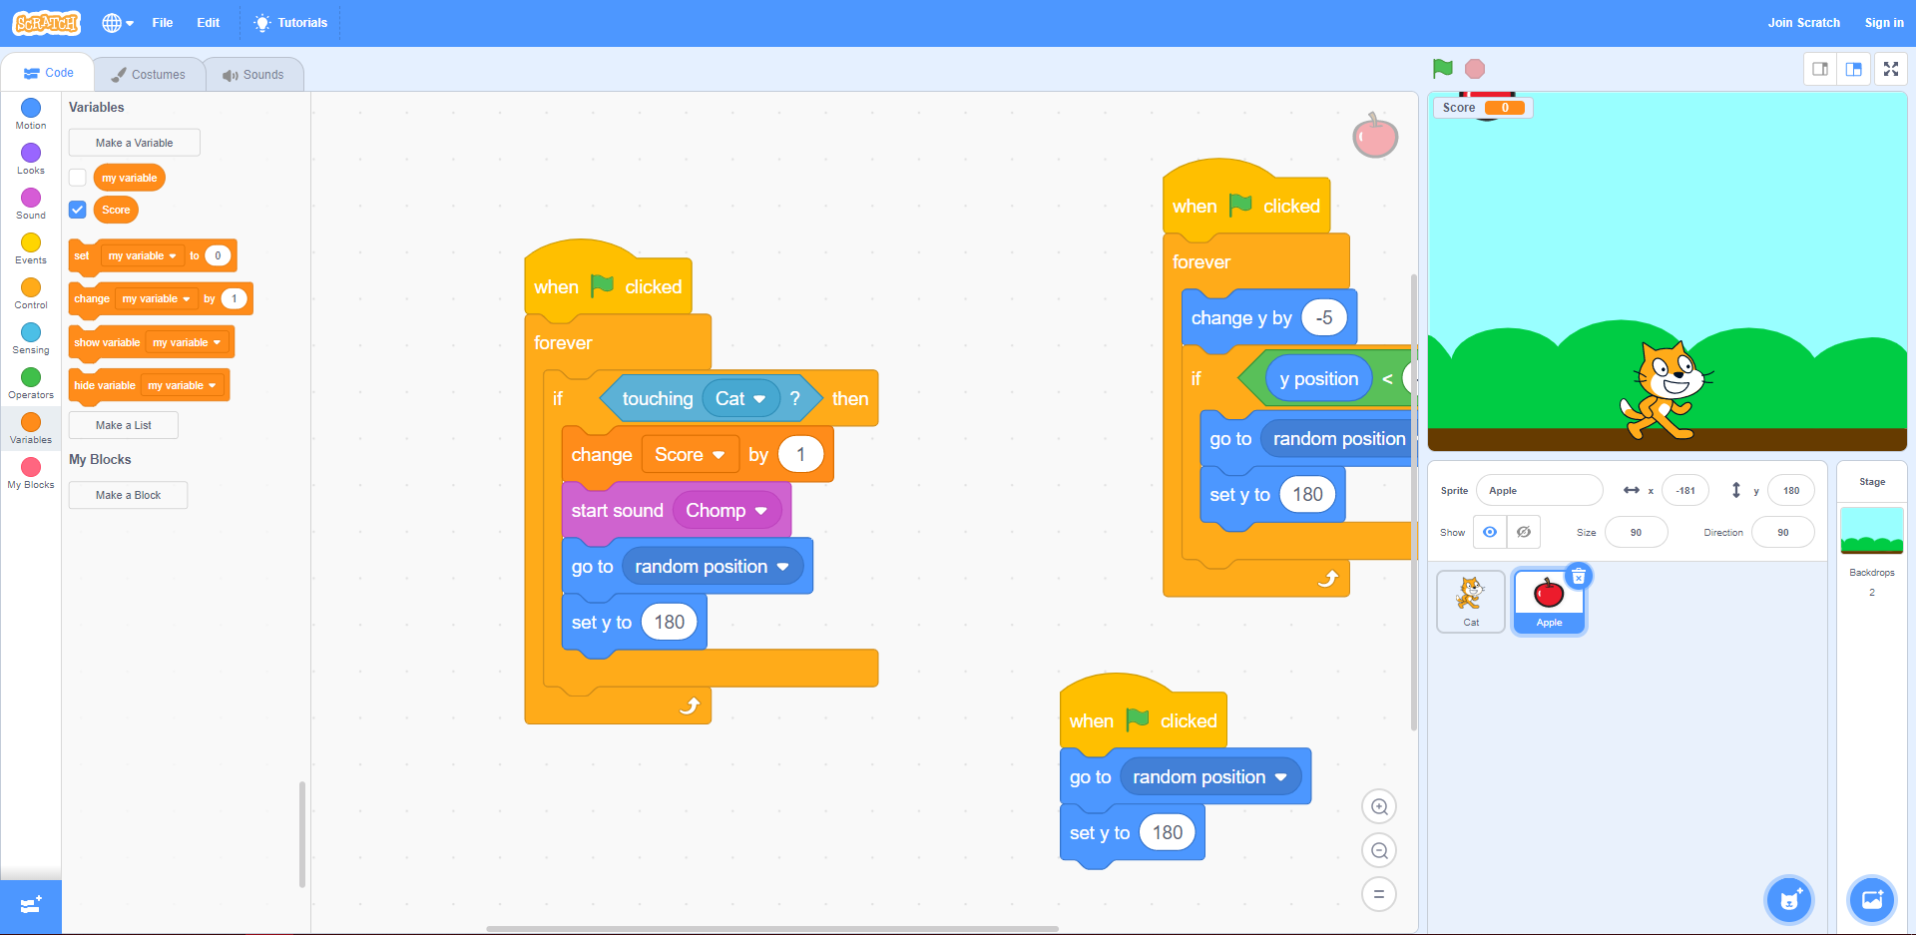

Step 3: Drag and drop the “set my variable to 0” block and place it after the “when green flag clicked” block and before the forever loop. Click the drop-down menu and select the variable “Score.” Now the score resets to zero every time we start a new game.

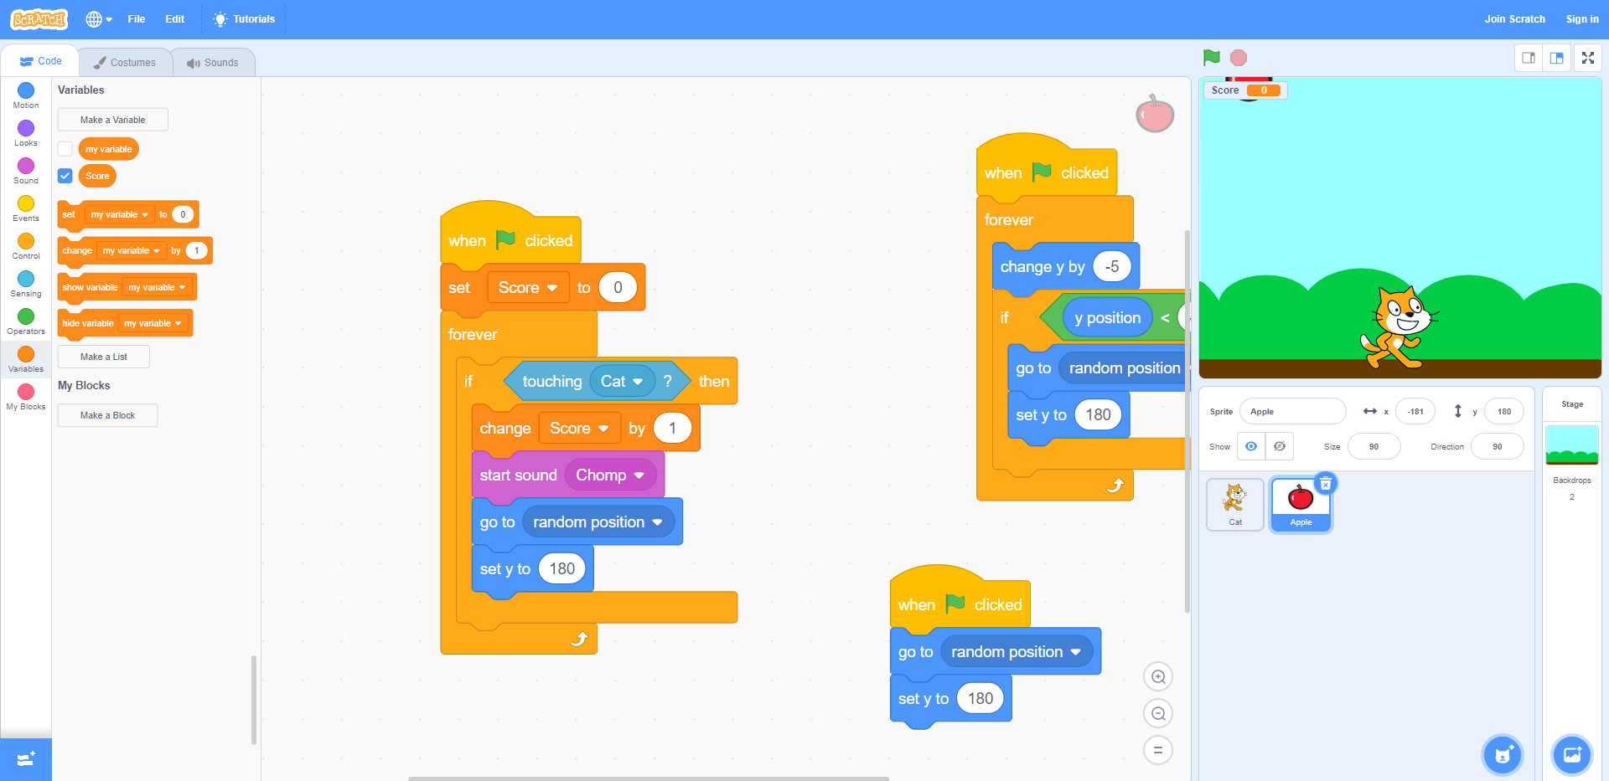

That concludes part five “Keep Score.”

There we go. That is a catch game!

Congratulations!